**Spring rest 1**

**Exercise 1:** **Create a Spring Web Project using Maven**

**Code:**

<parent>  
 <groupId>org.springframework.boot</groupId>  
 <artifactId>spring-boot-starter-parent</artifactId>  
 <version>3.5.3</version>  
 <relativePath/> <!-- lookup parent from repository -->  
</parent>  
<groupId>com.cognizant</groupId>  
<artifactId>spring-learn</artifactId>  
<version>0.0.1-SNAPSHOT</version>  
<name>spring-learn</name>  
<description>Demo project for Spring Boot</description>

<properties>  
 <java.version>21</java.version>  
</properties>  
<dependencies>  
 <dependency>  
 <groupId>org.springframework.boot</groupId>  
 <artifactId>spring-boot-starter-web</artifactId>  
 </dependency>  
  
 <dependency>  
 <groupId>org.springframework.boot</groupId>  
 <artifactId>spring-boot-devtools</artifactId>  
 <scope>runtime</scope>  
 <optional>true</optional>  
 </dependency>  
 <dependency>  
 <groupId>org.springframework.boot</groupId>  
 <artifactId>spring-boot-starter-test</artifactId>  
 <scope>test</scope>  
 </dependency>  
</dependencies>

@SpringBootApplication  
public class SpringLearnApplication {  
  
 private static Logger *LOGGER* = LoggerFactory.*getLogger*(SpringLearnApplication.class);  
 public static void main(String[] args) {  
  
 *LOGGER*.info("Starting application");  
 ApplicationContext context= SpringApplication.*run*(SpringLearnApplication.class, args);  
 *LOGGER*.info("End Application");  
 }  
}

**Output:**

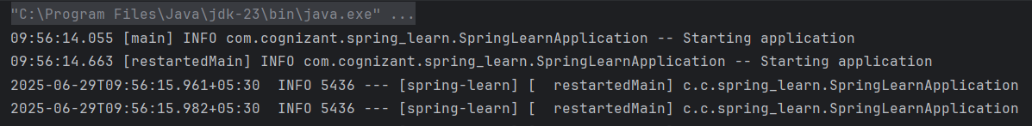

**Exercise 4:** **Spring Core – Load Country from Spring Configuration XML**

**Code:**

<bean id="country" class="com.cognizant.spring_learn.Country">  
 <property name="code" value="IN" />  
 <property name="name" value="India" />  
</bean>

public class Country {  
 private static final Logger *LOGGER* = LoggerFactory.*getLogger*(Country.class);  
 private String code;  
 private String name;  
 public Country() {  
 *LOGGER*.debug("Inside Country Constructor.");  
 }  
  
 public String getCode() {  
 *LOGGER*.debug("Inside getCode()");  
 return code;  
 }  
  
 public void setCode(String code) {  
 *LOGGER*.debug("Inside setCode()");  
 this.code = code;  
 }  
  
 public String getName() {  
 *LOGGER*.debug("Inside getName()");  
 return name;  
 }  
  
 public void setName(String name) {  
 *LOGGER*.debug("Inside setName()");  
 this.name = name;  
 }  
  
 @Override  
 public String toString() {  
 return "Country [code=" + code + ", name=" + name + "]";  
 }  
}

@SpringBootApplication  
public class SpringLearnApplication {  
 private static final Logger *LOGGER* = LoggerFactory.*getLogger*(SpringLearnApplication.class);  
 public static void main(String[] args) {  
 *displayCountry*();  
 }  
 public static void displayCountry() {  
 ApplicationContext context = new ClassPathXmlApplicationContext("country.xml");  
 Country country = context.getBean("country", Country.class);  
 *LOGGER*.debug("Country : {}", country.toString());  
 }  
}

**Output:**

